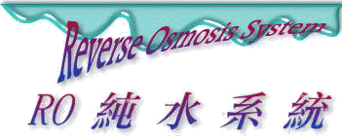
YT industrial Large RO systems 250-42000gpd

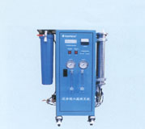  RS - 250 ~ RS - 800 | 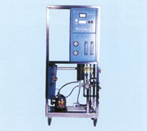  SA -1500 ~ SA - 9000

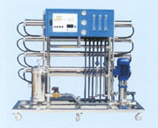  LA - 5000 ~ LA - 10000 | 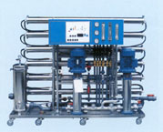  LA2 - 12000 ~ LA2 - 18000
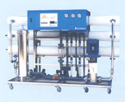  LBW - 35 ~ LBW - 70
  For larger capacity R.O System, please contact us.
  Custom-made design is available upon request.
  Additional options:
  Ultra - Filtration System, K-PLUS Series Deionizer And Mixed-Bed Deionizer.
Operation Pressure : 150 -220 PSI
Rejection : >97% (Organic, colloids, bacteria, and pyrogen are above 99.9% rejected.)
Recovery Rate: 50% ~ 75%

RO ALL SPECIFICATIONS
Model# | Flow Rates (GPD) |  | R.O Modules  (Model x Numers) |  | R.O Pump / Voltage |  | Pre - Filter | Dimensions (cm)  & Weight (kg)
RS - 250  RS - 500  SR - 800 | 250  500  800 |  | 2521*1  2521*2  4021*1 |  | 1/3HP,110V/220V  1/3HP,110V/220V  1/2HP,110V/220V |  | 5m, 20" * 1  1m, 20" * 1 | 73*40*113*56  73*40*113*58  73*40*113*60
SA - 1500  SA - 3000  SA - 4500  SA - 6000  SA - 7500  SA - 9000 | 1500  3000  4500  6000  7500  9000 |  | 4040*1  4040*2  4040*3  4040*4  4040*5  4040*6 |  | 1HP,110V/220V  3HP,220V/380V  3HP,220V/380V  4HP,220V/380V  5.5HP,220V/380V  5.5HP,220V/380V |  | 5m, 20" * 1  5m, 20" * 1  5m, 20" * 1  5m, 20" * 2  5m, 20" * 2  5m, 20" * 2 | 90*70*154*83  90*70*154*150  90*70*154*168  90*70*154*188  90*70*154*210  90*70*154*232
SA - 5000  SA - 7500  LA - 10000 | 5000  7500  10000 |  | 4060*2  4060*3  4060*4 |  | 3HP,220V/380V  5.5HP,220V/380V  5.5HP,220V/380V |  | TK10 * 1  TK10 * 1  TK10 * 1 | 210*70*178
LA2 - 12000  LA2 - 15000  LA2 - 18000 | 12000  15000  18000 |  | 4080*4  4080*5  4080*6 |  | 5.5HP,220V/380V  5.5HP,220V/380V  5.5HP,220V/380V |  | TK10 * 1  TK10 * 1  TK10 * 1 | 210*70*178
LBW - 35  LBW - 50  LBW - 70 | 21000  30000  42000 |  | 4080*2  4080*3  4080*4 |  | 5.5HP,220V/380V  7.5HP,220V/380V  15HP,220V/380V |  | TK14 * 1  TK21 * 1  TK21 * 1 | 230*80*178
Notes:
Feedwater Conditions
Inlet Pressure ------------- |  | > 1.5 kg/cm² |  | Chlorine -------------- |  | < 0.1 ppm
Total Hardness ----------- |  | <10 ppm |  | Turbidity ------------- |  | < 2 NTU
Fe ----------------------------- |  | < 0.1 ppm |  | SDI -------------------- |  | < 4

Features
   | a. | Automatically operates and PLC control device.
   | b. | Automatic flush device.
   | c. | Low-pressure protection switch.
   | d. | Product Hi-level control.
   | e. | Over - heat protection device for pump.
   | f. | Concentrate recycle-flow regulator.
   | g. | Digital feed/ product water quality meter.
   | h. | Operating pressure set-up device.
   | i. | Automatic power shut-off device if pre-treatment system is in regeneration process.
   | j. | Chemical cleaning system.
   | k. | All # SUS 304 made skids except the RS-series.
   | l. | Includes one standard Hi-pressure R.O Pump; optional two parallel Hi-pressure R.O Pumps are also available.

DM-W-RO ALL -250-42000-單主機規格表-200508

